ECM1414

Data Structures and Algorithms

Coursework | Group 35

Max Thrift-Brothers

Cameron Russell

Utku Ozturk

Note: When converting to PDF, rename file to “Report.pdf”.

Formatting Rules:
- For subheading colour, use #0E2841
- For subheadings, use 16pt
- For sub-subheadings, use 14pt and same colour as subheadings
- For regular body text, use Courier New
- For code snippets, use Consolas
- For code snippets, use highlight colour “Grey-25%”
- For body text size and code snippets, use 12pt
- For body text colour, use Automatic

Table of Contents
- Introduction .......................................... 3
- Design and Approach ................................... 4
  - Prerequisites and Dependencies ................... 4
  - Program Structure ................................ 4
  - Data Structures .................................. 4
- Algorithms ............................................ 6
  - Brute Force ...................................... 6
  - Dynamic Programming .............................. 6
- Testing and Results ................................... 9
  - input_small ...................................... -
  - input_medium ..................................... -
  - input_large ...................................... -
- Generative AI Statement ............................... 12
- References ............................................ 12
Note: Each page number is linked to the specific heading, so if the heading changes page number, these numbers will automatically update once pressing ‘Ctrl+a’, then ‘F9’, which forces Word to update the page references.

TODO: Add page references and links to the input files in the testing section (Cameron)!

1. Introduction
A university society committee is planning to host an event-weekend. They have a selection of activities to put on, but don’t know which subset of activities to choose. They would like to maximise the enjoyment of the society members whilst staying within their available budget.

Our project aims to analyse a list of activities that this society could undertake and determine the optimal selection of activities to host.

We have achieved this using two algorithms: a brute-force approach and a dynamic programming approach. Both approaches are timed, and their respective solutions are output in a human-readable format.

2. Design and Approach

Prerequisites and Dependencies
Our project was implemented using Python 3.13 and used several built-in libraries:
- sys - used to extract terminal arguments and terminate the program.
- pathlib.Path - used to construct the file path to the specified sample file, whilst being platform independent.
- time - used to measure the execution time of each algorithm.
- itertools.combinations - used to generate all subsets of a given size.

Program Structure
We have aimed for a modular program structure which aids collaborative development and maintainability.

Each algorithm is implemented in its own Python module: brute_force.py and dynamic_method.py. Each module is imported and used within a main program called event_planner.py.

The purpose of event_planner.py is to communicate with and link all three helper modules. Its main job is to receive the optimal solution calculated by each algorithm and output each in a human-readable format.

The third helper module is named file_input.py, and its job is to parse the input file, ensuring it is in the correct format for the two algorithms to analyse.

Data Structures
We chose to use a Python list to store the activities in, because we required a mutable data structure with direct access and that could store elements of different sizes.

Each element of this list is a tuple, because an immutable data structure that could store elements of different data types was necessary, since each activity's data doesn’t need to change once parsed from the input file and consists of different types.

The first tuple, within this list, contains the metadata for that particular input file: number of activities, available time, and available budget. All subsequent tuples contain the data for each respective activity: activity name, required time, required cost, and enjoyment value.

Both algorithms utilise a dictionary to store the optimal solution, because it is a convenient structure to store multiple types and sizes of data. This dictionary’s structure is as follows:
Key | Value
subset_indices / subset | The optimal activity subset.
time_used | The total number of hours this subset requires.
budget_used | The total cost of this subset. Always <= available budget.
total_enjoyment_value | The total enjoyment that society members will experience.

3. Algorithms

Brute Force
My implementation of the brute force approach involves systematically generating all subsets of a given size and evaluating each subset against the budget constraint, whilst ensuring this subset improves the enjoyment value. My algorithm then repeats this process for all sizes of subsets until it has exhausted all possibilities.

Once finished, my algorithm will have found the optimal selection of activities that maximises the enjoyment value, whilst adhering to the budget constraint.

To return the optimal solution, my algorithm packages up the chosen subset, time used, budget used (always <= available budget), and total enjoyment value within a dictionary. This dictionary is then returned to the event_planner.py module to be output in a human-readable format.

As mentioned in the Design and Approach section, all the logic for the brute force approach is contained within the Python module brute_force.py. Within this module, there are two functions: find_optimal_solution() and generate_subset().

The find_optimal_solution() function contains the logic to evaluate each subset.

Pseudocode for ... TODO
...

The generate_subset() function utilises the combinations function from the built-in module itertools to generate all subsets of a given size. I have chosen to extract this operation into a standalone function so that a custom subset calculator could be easily implemented in the future. This idea links back to the maintainability design aspect mentioned in the Design and Approach section.

Dynamic Programming
All of dynamic programming is contained within the dynamic_method.py file; it utilises a 2-Dimensional Dynamic Programming table to keep track of previously computed results and uses them to compute the next set of activities. This approach keeps the time complexity and cost of computation low.
- For code snippets, use Consolas
- For code snippets, use highlight colour “Grey-25%”

Pseudocode for creation of table:

CREATE dp_table as an array

FOR i from 0 to num_activities DO
CREATE a row with length of av_budget, each with 0
ADD a row to table
END FOR

FOR i from 0 to num_activities DO
act_cost <= cost of activity i
act_enjoy <= enjoyment of activity i

FOR t from 0 to av_budget DO
IF act_cost <= t THEN
dp_table ADD MAX(dp_table[t-1][i], dp_table[t-1][i -act_cost] + act_enjoy to [t][i]
ELSE
dp_table ADD dp_table[t-1][i] to [t][i]
END IF
END FOR
END FOR

Pseudocode for data extraction of DP table:

CREATE LIST subsets
SET remaining_budget <= av_budget
SET total_time <= 0
SET used_budget <=0
SET total_enjoyment <= 0

FOR i from num_activities to 0 do
act_cost <= cost of activity i
act_enjoy <= enjoyment value of activity i
act_time <= time for activity i

IF budget >= act_cost and dp_table[i][budget] != dp_table[i-1][budget] do

ADD activity i to subsets
budget <= budget – act_cost
total_time <= total_time – act_time
total_enjoy <= total_enjoy + act_enjoy
required_budget <= required_budget + act_cost
END IF
END FOR

OUPUT subsets, total_time, required_budget and total_enjoy

This algorithm traverses the DP table backwards, adding the activity if the results of adding it improve the subset without going over budget.

By using a dynamic method like this, with a DP table, the overall time complexity and efficiency of solving such a problem are reduced. The table has a size of number of activities by available Budget, therefore the overall time complexity is O(nB), which is better than quadratic time, but not as good as linear time.

4. Testing and Results
To test our program, we will be performing several tests, from basic data and erroneous entry to large file inputs.

Test 1
Test of erroneous file input name
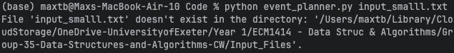
Passed, correctly informs user file does not exist

Test 2
Test of no file input given

Test 3 - input_small
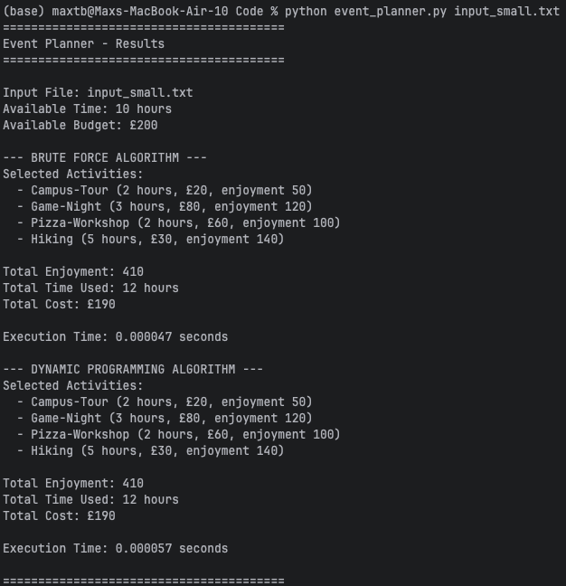
For the list of 5 possible activities, the Brute Force method took 4.7x10⁻⁵s to compute, whereas the dynamic method took, 5.7x10⁻⁵s.

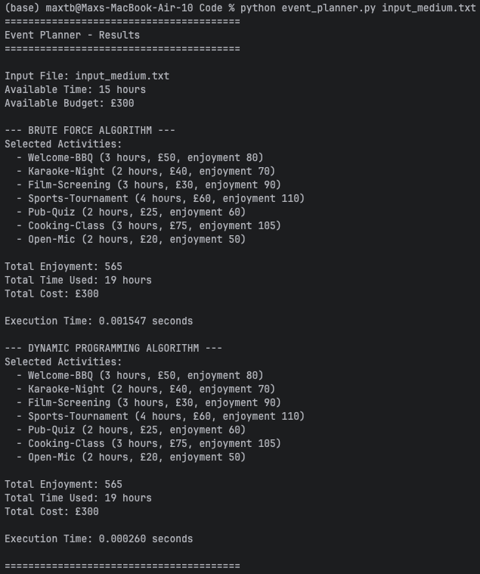
Test 4 - input_medium
For the list of 12 possible activities, the Brute Force method took 1.5x10⁻³s to compute, whereas the dynamic method took 2.6x10⁻⁴s.

Test 5 - input_large
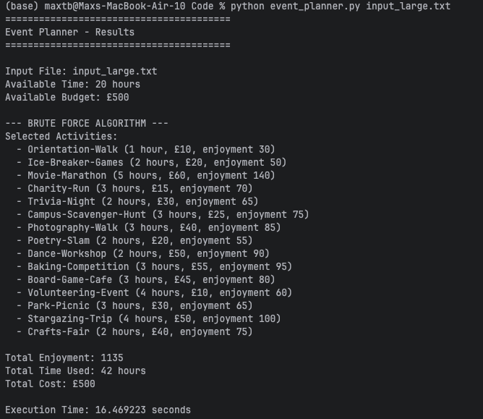
For the list of 25 possible activities, the Brute Force method took 16s to compute, whereas the dynamic method took 7.9x10⁻⁴s.
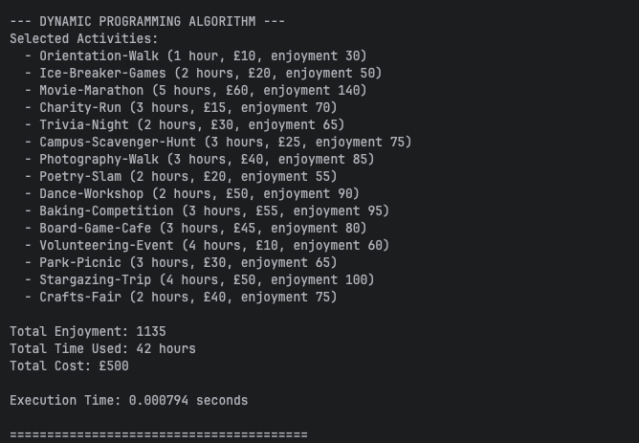
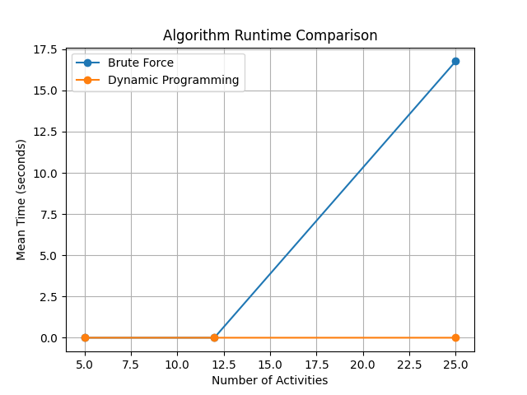
This graph illustrates the relationship between the number of activities in a dataset and the time it took to compute. By using the average time over 10 tests of both algorithms for each of the small, medium and large files.
All of these tests have been performed on a 2024 MacBook Air, M3 with 16GB of RAM on the latest versions of all software, using PyCharm Pro.

5. Generative AI Statement
...

Note: These two sections should be able to fit on a single page.

6. References
- Reference online documentation on how to use itertools.combinations.
- Referenced documentation for using DP tables:
- https://www.geeksforgeeks.org/competitive-programming/dynamic-programming/
...

Q: Shall we use the Harvard referencing style?

